PROPOSAL PROJECT 2: Lisa, Keely, Francis, Mark

1. Find which jobs and tools are most required for data scientist, data engineer, and data analyst
   1. Indeed dataset has US state data
   2. Glass door dataset has international data
   3. LinkedIn dataset has international data
2. D3 x and y interactive axes
   1. Y-Axis: frequency of languages/tools, mean starting salary
   2. X-Axis: job categories
3. Leaflet incorporates all data
   1. Use same metrics as D3 axes for popups

Clean up data either before, or ideally in, mongoDB (Francis, Keely help) to isolate the metrics we want for axes and popups. Get DB files to repo asap -NOTE: if using SQLite is easier for sending files we can do that, you can precompile it and upload it if we look up a few things

Specific Requirements:

1. JavaScript with D3 rendered in HTML with CSS (D3/HTML - Mark, CSS – Lisa), served up with python Flask app connected to MongoDB where data is stored (Lisa), leaflet(Lisa)
2. Track: A custom “creative” D3.js project (i.e., a nonstandard graph or chart), adding leaflet visualization on another page
3. 3 datasets, 1+ having 100+ records
4. User interacts with clickable axes in D3 plot as well as d3-tip.js plugin tool tips, user interacts with map on Leaflet as well as the datapoints by triggering popups
5. Final visualizations will provide 9 possible D3 plot views, Leaflet provides as many different visualizations as the user desires
6. Presentation: powerpoint (Keely), each member presents their piece of the code and data preparation (Francis/Keely)

Datasets:

Glassdoor: <https://www.kaggle.com/defrinogionaldo/glassdoor-jobs-data-analysis?select=glassdoor+job+posting.csv>

Indeed: <https://www.kaggle.com/elroyggj/indeed-dataset-data-scientistanalystengineer>

LinkedIn: <https://data.world/crowdflower/data-behind-data-scientists>

Inspiration:

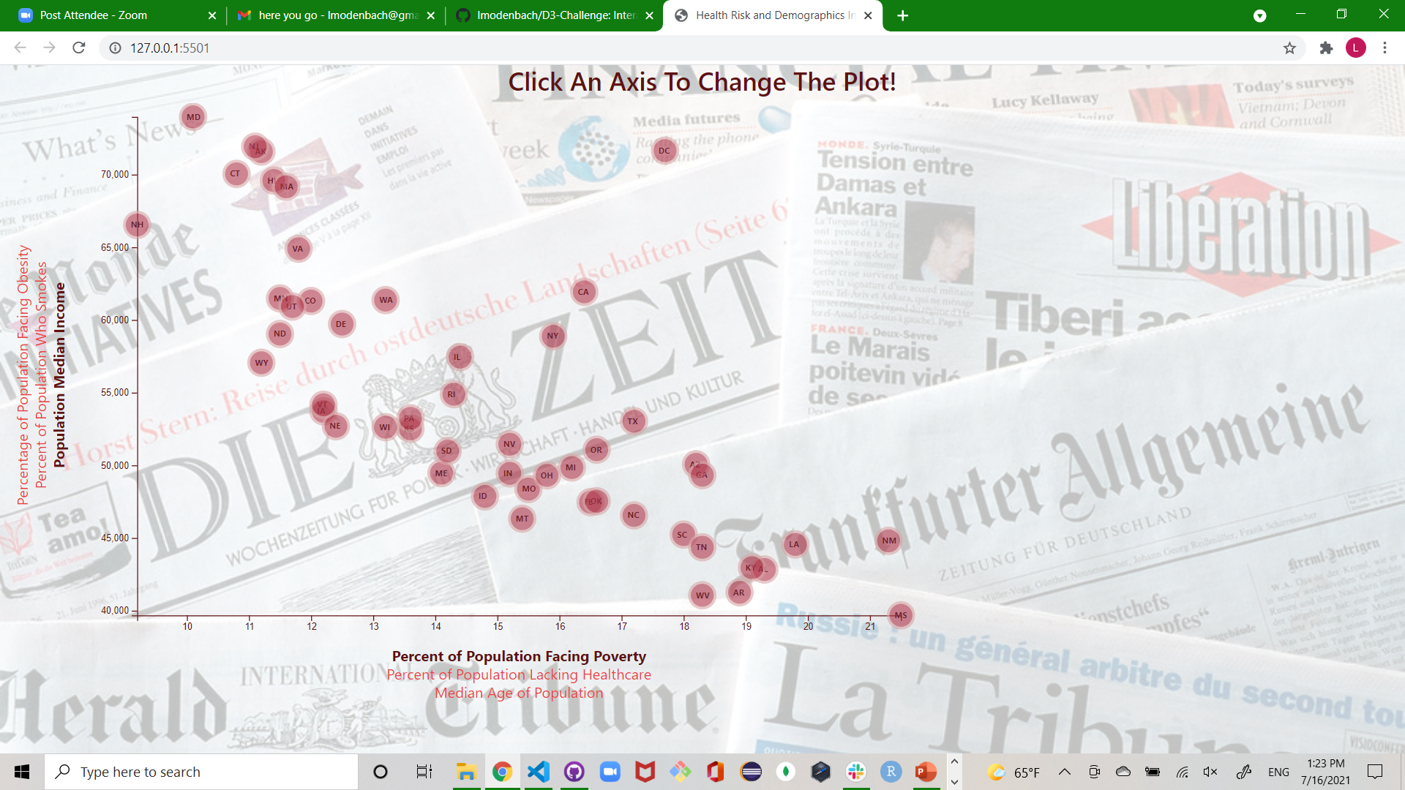

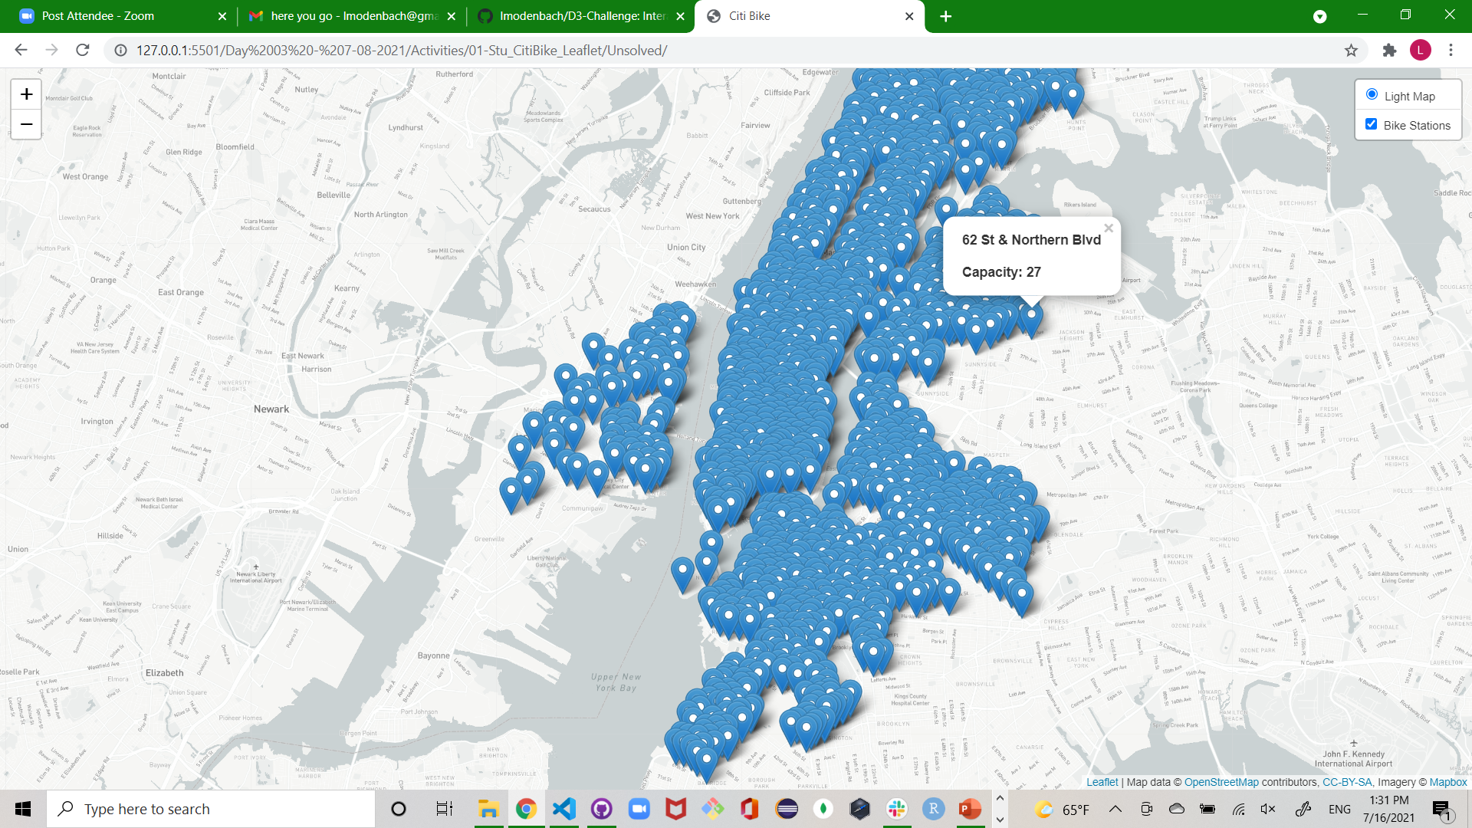

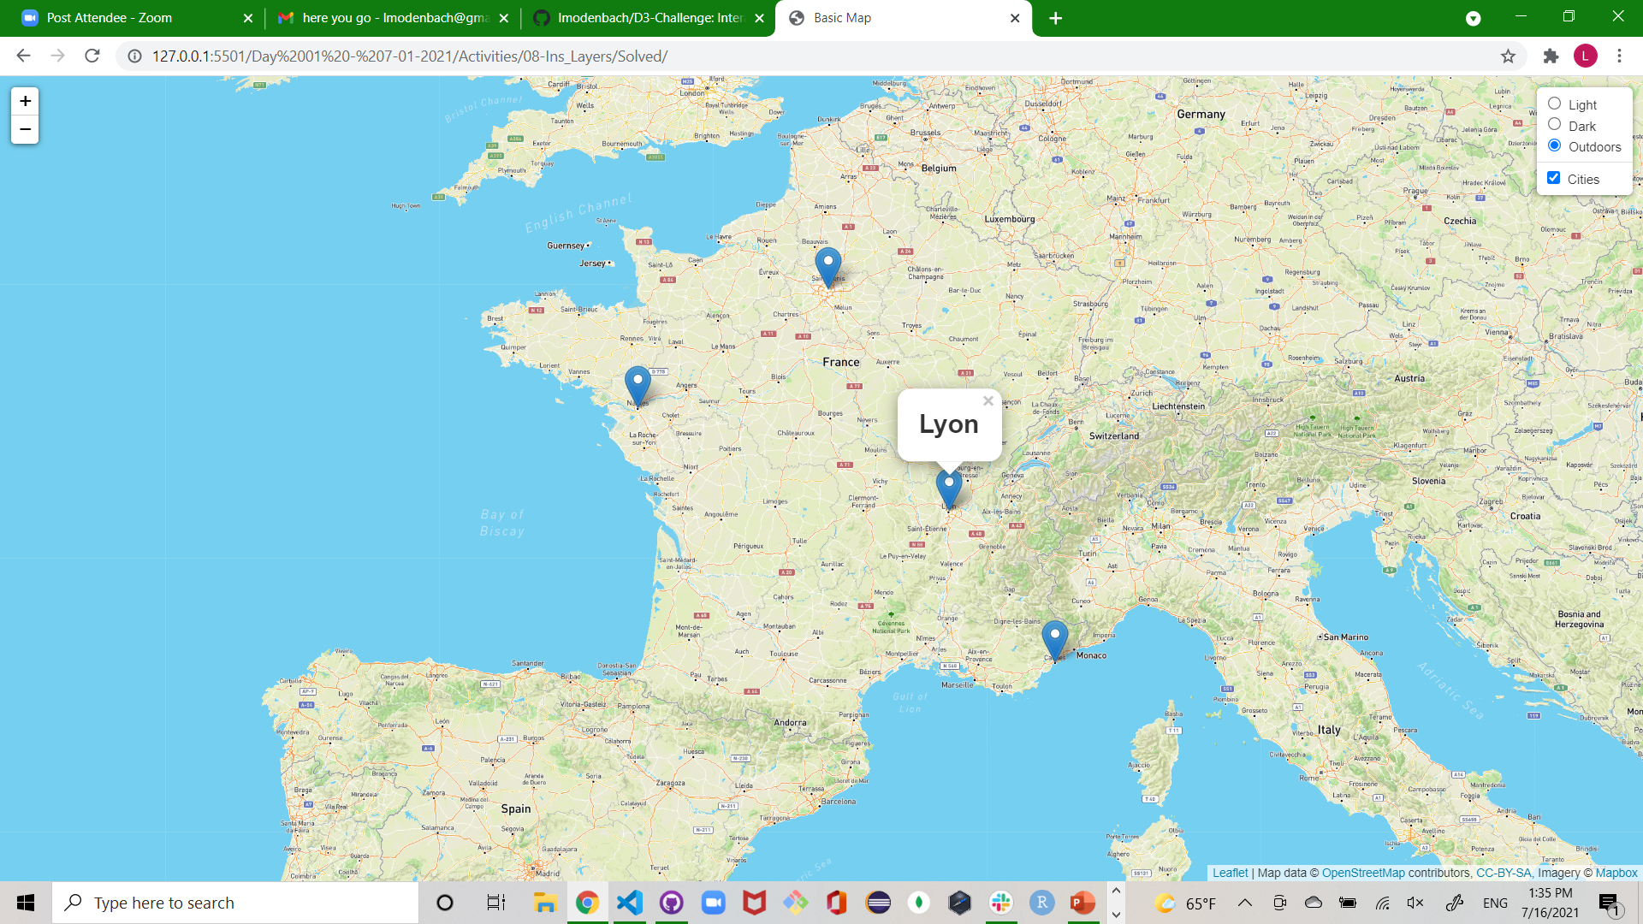

Concept Sketches:

Homepage

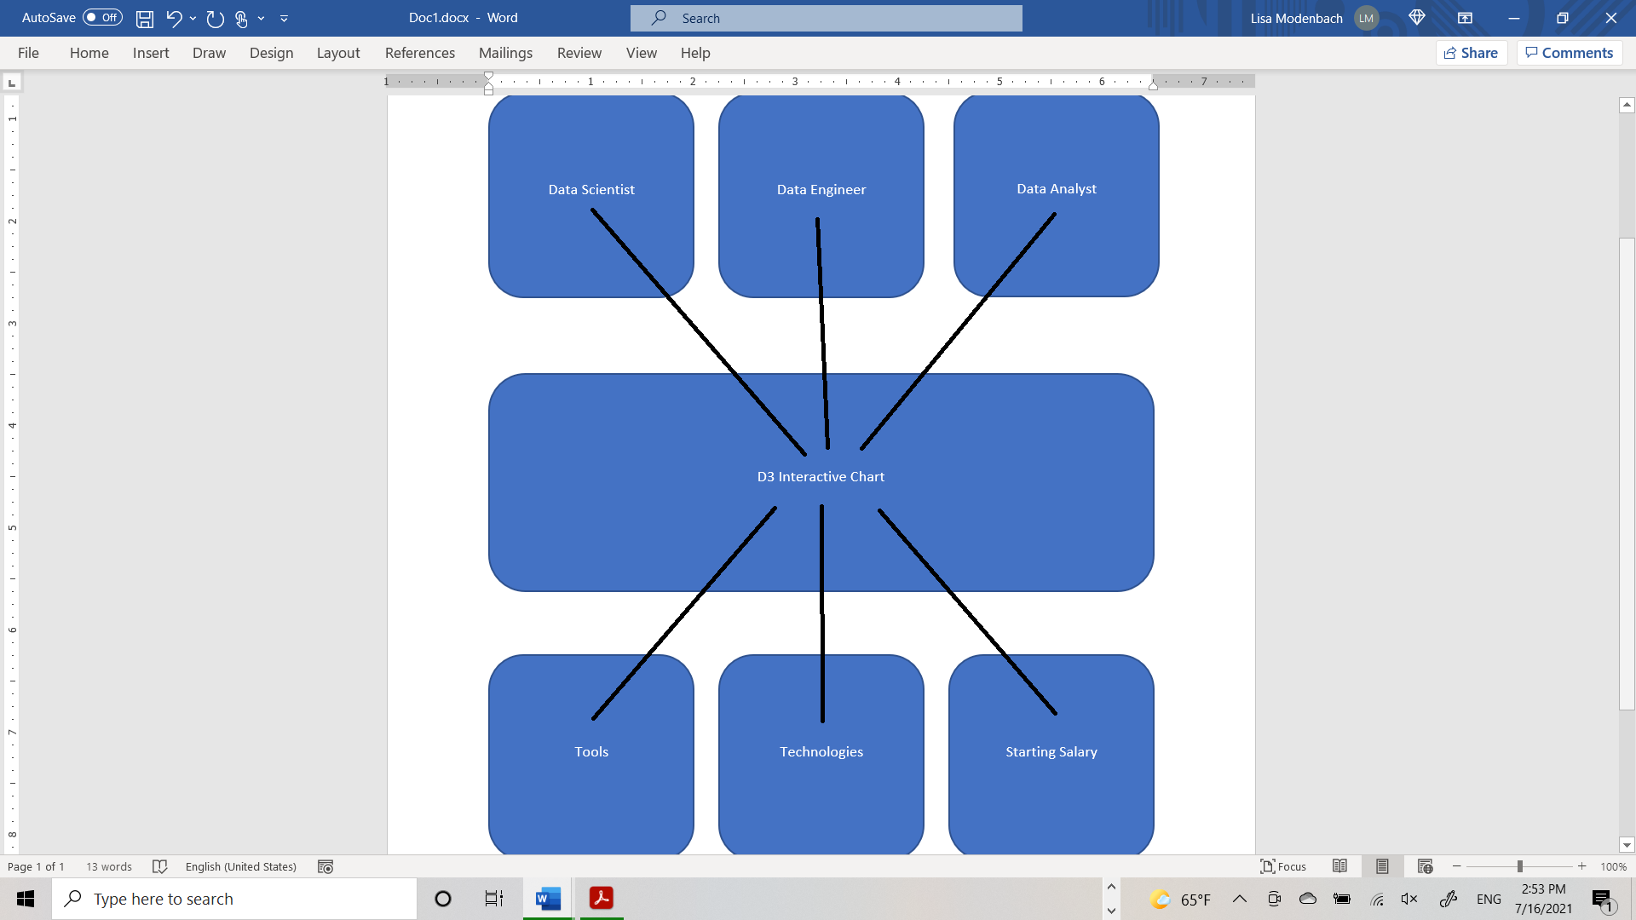

Linked Page

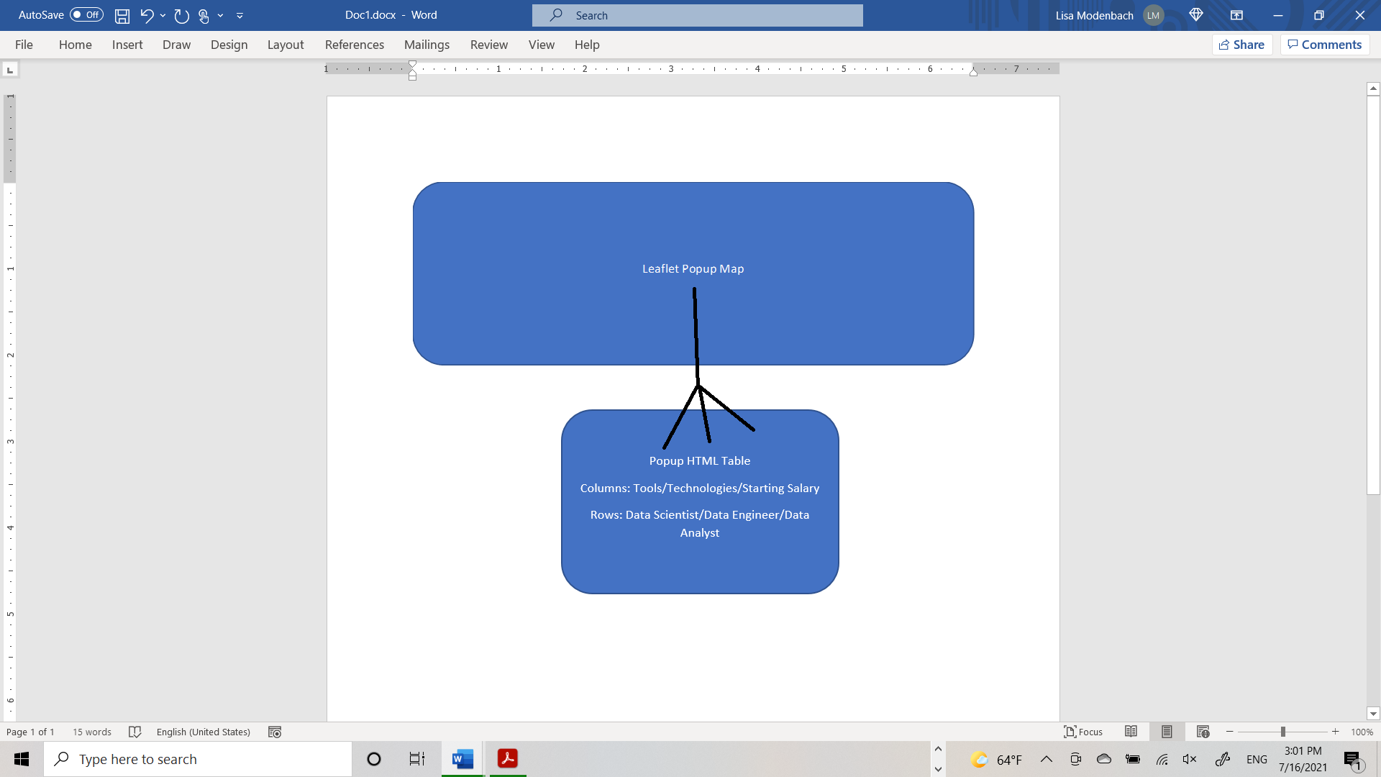

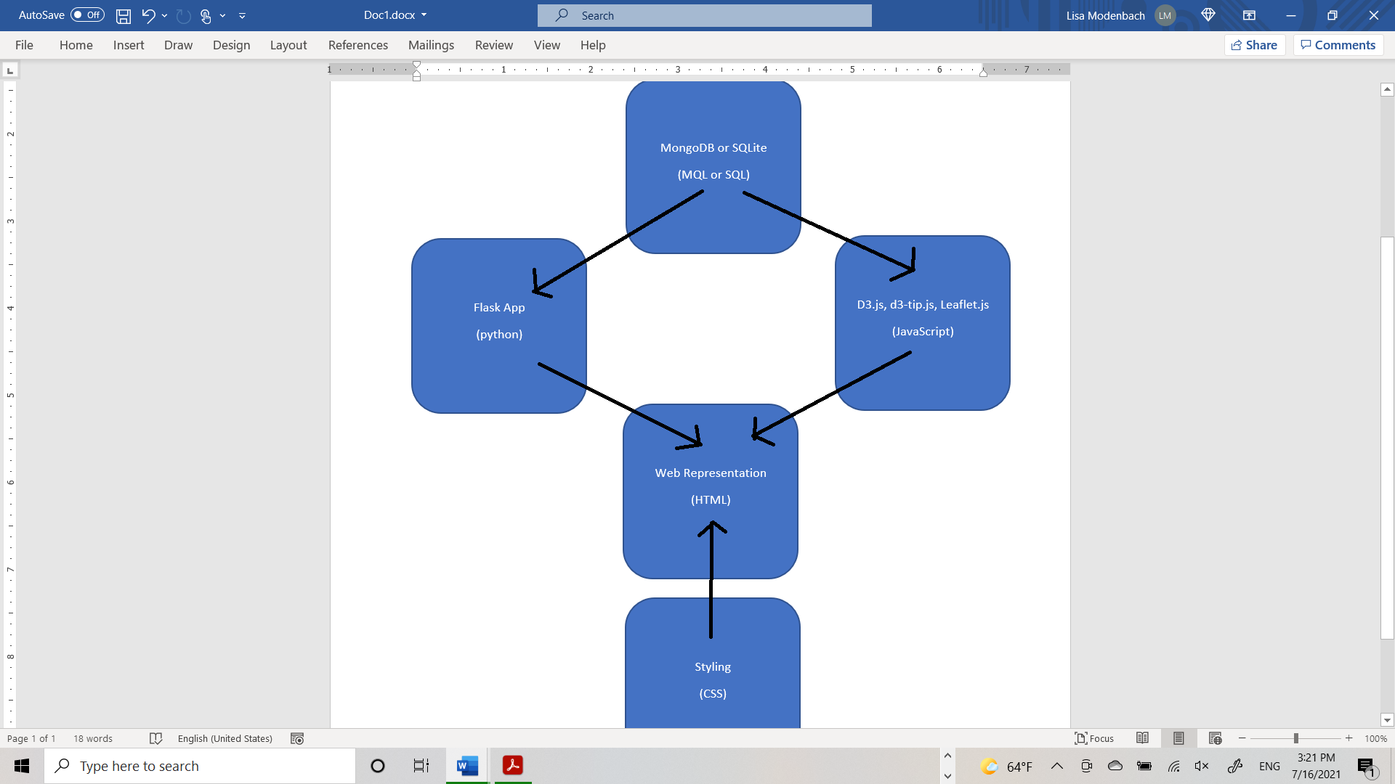

Our GitHub: <https://github.com/The-Data-Analytics-of-Data-Analytics/Project2.git>